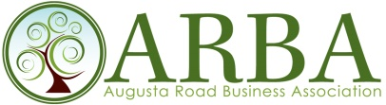

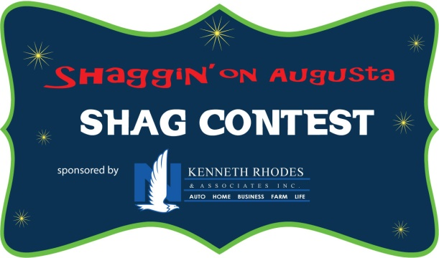

Sponsored By – YOUR LOGO

This event takes place Saturday, June 16, 2018 from 5:30 to 8:30 p.m. and had the most people in attendance for the 2017 festivities.

SHAG CONTEST SPONSOR - $1,600
Marketing Benefits:
- Your business named the Shag Contest sponsor
- Recognized in the Shag Contest logo (see above).
- Posters printed
- Your business mentioned as the sponsor each time the contest is promoted. For instance “Summer on Augusta 2018, presented by Virginia Hayes, is coming in June and the community is getting excited to hear just who the dance contestants will be for the Shaggin’ on Augusta Shag contest sponsored by YOUR BUSINESS”.
- Promotion with your links and logos on the website
- Article written about your sponsorship for ARBA’s news updates and shared virally and through email blasts.
- Ability to speak during the event and emcee the contest – this would be great exposure!
- Ability to place your own banner in a location at the event.
- Ability to set up a table or tent with information about your business.
- Ability to make the grand announcement of the 2018 contestants and instructors.
- Promotion through social media, website, public relations and e-blasts

We are happy to discuss other possible benefits that you feel would help your organization and the event.

